Name: Teagan Clark
A company wants to understand which factors influence whether a house's price is above or below its median value in a given dataset. The dataset contains the following variables for 75 houses:
- square_feet (total square footage of the house)
- bedrooms (number of bedrooms)
- bathrooms (number of bathrooms)
- lot_size (size of the lot in square feet)
- year_built (year the house was built)
- garage (number of garage spaces)
- location (categorical variable: 1 = Urban, 2 = Suburban, 3 = Rural)
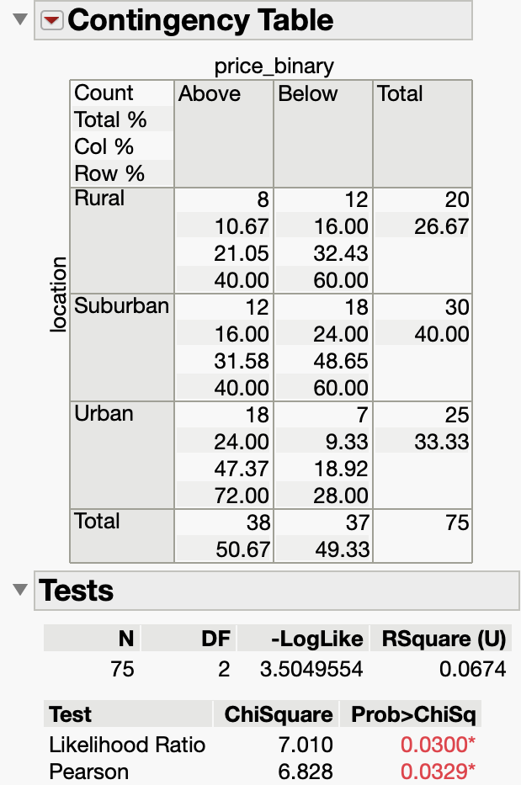
Tasks:
- Calculate the median house price. Use this value to create a binary variable (called price_binary) indicating whether a house’s price is equal to or above ("Above") or below ("Below") the median price in the dataset.
  - Median house price = $790,000 (via tabulate)
- Perform a Chi-Square test of Independence to determine if there is a significant relationship between the location of the house and whether its price is above or below the median. Calculate the odds of being Above the median price for Urban, Suburban, and Rural houses. Which location type has the highest odds of having a house Above the median price?
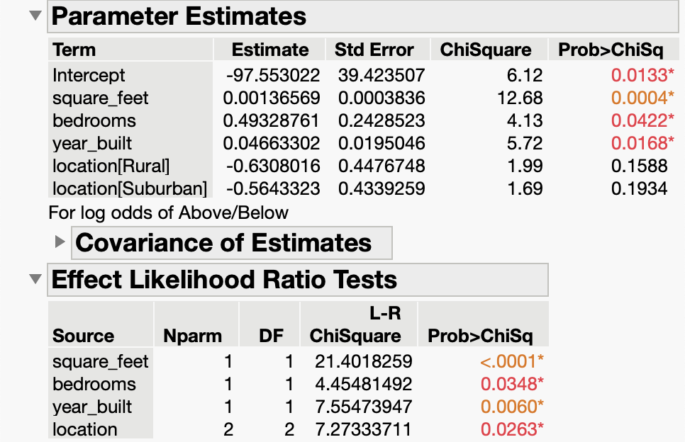
  - Likelihood Ratio p-value = .03 < .05 (there is a significant relationship between the two)
  - Odds: Rural Above = .667:1, Suburban Above = .667:1, Urban Above = 2.571:1
  - Urban has the highest odds of having a house price above the median
- Estimate and interpret a Logistic Regression model using price_binary as the dependent variable and the other factors as independent variables. Identify the best model using the given predictors. Your answer to the Logistic Regression part should include:

Reference p-values and explain which variables are significant.
Using the Effect Likelihood p-values, after removing the insignificant ones stepwise (garage, then lot_size, then bathrooms), the remaining significant variables are square_feet (<.0001), bedrooms (.0348), year_built (.0060), and location (.0263).

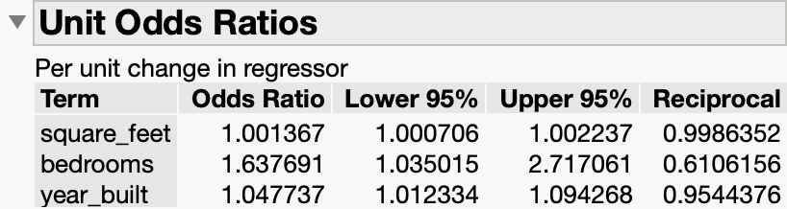
Interpret the coefficients using Odds Ratios of the significant variables.
for every additional sq ft, the odds that the house price is above the median increase by 0.13%
for every additional bedroom, odds that the house price is above the median increase by 63.77%
for every additional year newer, odds that the house price is above the median increase by 4.77%

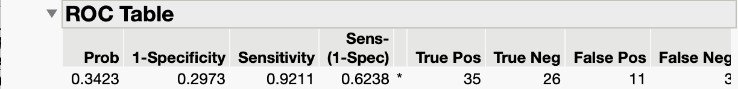
Choose a prediction threshold for classification from the ROC table.
prediction threshold = .3423
Calculate the sensitivity and specificity of the model using that threshold.
Sensitivity = .9211, Specificity = .7027
Best Model:
if Rural: $\frac{e^{-97.553022 + .00136569(Square Feet) + .49328761(Bedrooms) + .04663302(Year Built) - .6308016 (1)}}{1 + e^{-97.553022 + .00136569(Square Feet) + .49328761(Bedrooms) + .04663302(Year Built) - .6308016 (1)}}$

if Suburban: $\frac{e^{-97.553022 + .00136569(Square Feet) + .49328761(Bedrooms) + .04663302(Year Built) - .5643323 (2)}}{1 + e^{-97.553022 + .00136569(Square Feet) + .49328761(Bedrooms) + .04663302(Year Built) - .5643323 (2)}}$

- Use the model estimates to predict the probability of being Above or Below the median price for the following house:
square_feet | bedrooms | bathrooms | lot_size | year_built | garage | location
2,500 | 4 | 2 | 7,000 | 2010 | 2 | 2 (Suburban)

p = $\frac{e^{-97.553022 + .00136569(2500) + .49328761(4) + .04663302(2010) - .5643323 (2)}}{1 + e^{-97.553022 + .00136569(2500) + .49328761(4) + .04663302(2010) - .5643323 (2)}}$ = .7357 > .3423
so we predict that this house has a 73.57% chance for its price to be above the median.

